- We give God the glory for enabling to continue our mission despite the pandemic  Let us not become weary in doing good, for at the proper time we will reap a harvest if we do not give up.  Galatians 6:9  We sincerely thank all our donors, partners in ministry for your generous giving, continued support.  “The true test of a civilization is the way it treats its old people”. - David l-  - CBOH partners with BOH, Gotlam Is engaged in transforming lives of many children, young adults in poverty driven areas in the eastern part of province of Andhra Pradesh. India  - Contact Us  Canadian Bridge of Hope  115 Stratton Road, SE  Medicine Hat, AB.T1B 0G1  Phone : 403 -548-0084  Email:cboh2012@gmail.com  Web:canadianbridgeofhope.com | CANADIAN BRIDGE OF HOPE- Newsletter, December 2020  Greetings to you from Canadian Bridge of Hope. It is that time of the year as we reflect on the good things God has enabled us to do through CBOH. Though this covid 19 seems to be never ending, activities in Bridge of Hope have resumed partially after a few months of complete lockdown.  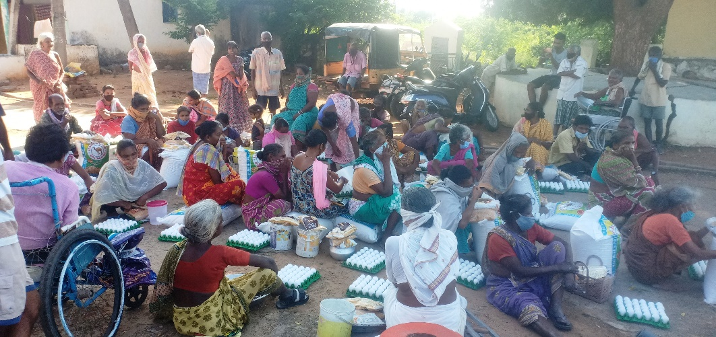  As the country of India is battling poverty worse than ever due to covid,  CBOH was able to assist 195 + families in several villages with food, hygiene and medical supplies for the months of April, May and September 2020. These are mainly families of children who are in Step up program and also the leprosy colony. This enables them to stay healthy, fight covid physically and to continue to experience God’s love for them.  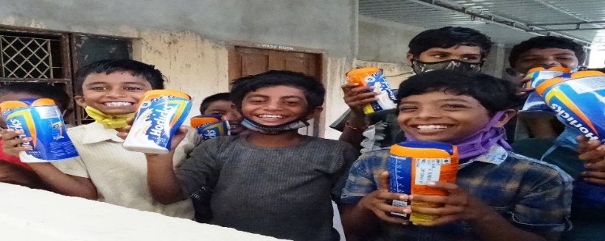  CBOH provided funds to medical outreach camps for 400 + people who cannot afford basic medical care during January to March -2020. Some of these camps were not possible due to covid restrictions during the last six months.  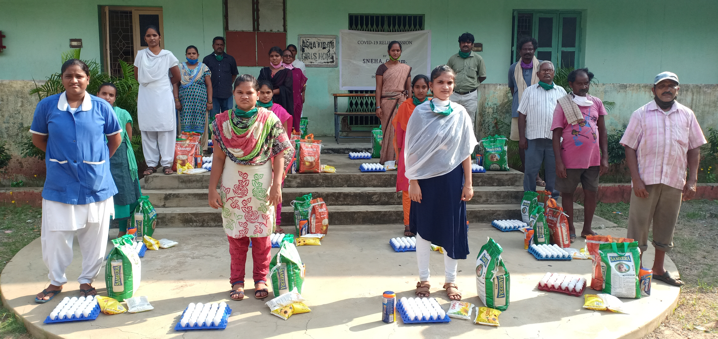  Hillcrest church team, led by Pastor Jamie, visited BOH in Feb 2018, and were able to pour their love in the hearts of BOH. They also provided funds to drill a bore well, purchase a surgical bed, and bless BOH in many ways.  The staff also were appreciated for their continuous work in many areas of ministry despite covid.  CBOH provided funds for developing the community of the leprosy colony as these families never receive any care from local authorites. As a result of this, they will be provided with clean drinking water and a renewed classroom for children.  Beside these CBOH also assisted in getting new kitchen appliances for the children at Asha Kiran. Nearly 3900 patients received out patient care, around 248 eye surgeries were completed, 354 received inpatient care and 5700 lab tests were done from Shalom medical center, BOH.  Next year, 2021 brings us immense hope despite of the current covid.  We have a God who is the King of the world. The Hospital construction will be expanding into the next floor for more services for patients.  Special thanks to Gary, Randy for their continuous support.  Statistics say there will be more than 150 million people around the world in poverty due to covid with India being heavily affected. This is so disturbing but we have faith in God who will enable us to be light in these dark times.  We sincerely thank all our donors, for your continuous support and valuable prayers.

